**Probability and Statistics - IT2120**

**Name:Ranaweera K.R**

**IT24103826**

**Exercise**

**1. Assume that the time taken to bake a batch of cookies is normally distributed with mean 45 minutes and standard deviation 2 minutes.**

1. **Generate a random sample of size 25 for the baking time.**

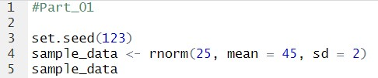

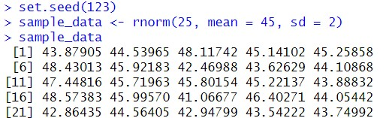

1. **Test whether the average baking time is less than 46 minutes at a 5% level of significance.**

